**Documentation**

**Hospital Management System**

**SUBMITTED** **BY:**

* **NAGAKAVYA**
* **KUMARI SHWETA**
* **KAJAL DAS(TEAM LEADER)**
* **NIDHI RAY**

**SUBMITTED** **TO:**

* **HEMANT** **SHRIVASTAVA**
* **VIDHYA** **LAKSHMI**

**Hospital Management System Project C#**

In this [asp.net project](https://meeraacademy.com/download-asp-net-project-with-source-code/) post we will discuss about Hospital Management System Project. We will be learning all modules, features and functions of project in this post.

The Hospital Management System project name gives us idea, what should be in it. The Hospital Management System is a computer software system, which is used to managing the functioning and events of any hospital or multi-speciality hospital. Now, there is a trend to build multi-speciality hospital to admit patient of any disease.

We developed HMS application project in .net C# with SQL server database.

**Software Specification:**

**Operating System:** Windows XP

**Programming language:** .NET

**Web-Technology:**  ASP.NET 2.0, HTML & CSS

**Front-End:** C#.NET

**Back-End:**  SQL Server 2000

**Web Server:** IIS

## Hospital Management System Project Modules:

* **Login**
* **OPD registration**
* **IPD form**
* **Doctor**
* **Department**
* **IPD ward**

**Login:**

In this module, Login id, password and role id credentials are used and submit.

|  |
| --- |
|  |

**Login id:**

|  |
| --- |
|  |

**Password:**

|  |
| --- |
| **Submit** |

**Registration:**

In this module, Rid, Name, Gender, Email, Phone number, Address and submit.

|  |
| --- |
|  |

**Rid:**

|  |
| --- |
|  |

**Name:**

|  |
| --- |
|  |

**Gender:**

|  |
| --- |
|  |

**Email:**

|  |
| --- |
|  |

**Phone no:**

|  |
| --- |
|  |

**Address:**

|  |
| --- |
| **submit** |

**OPD registration:**

OPD management software designed for clinics of all sizes. This cloud-based software offers useful features to take care of asset management, case management, patient location/monitoring management, disease/surgery/discharge management, patient flow management appointment/admission/bed/prescription management to help healthcare centers deliver patient-centered services.

**IPD form:**

The basic feature that a medical software must have the ability to admit a patient effortlessly. It should assign the ward and the patient’s respective bed based on his medical preferences and requirements. Also, the software should have the ability to add the contact information of first-response persons in case of an emergency.

**Doctor:**

When the patient wants to have an appointment, he might choose among a few options. Firstly, you can find the data about visiting hours on the medical specialists’ profiles and book a convenient time.

**Department:**

There are several departments are found in hospitals namely Outpatient department (OPD), Inpatient Service department (IPD), Medical Department.

**IPD ward:**

An inpatient department or IPD is a unit of a hospital or a healthcare facility where patients are admitted for medical conditions that require appropriate care and attention. An Inpatient department of the hospital is equipped with beds, medical equipment’s, round the clock availability of doctors and nurses.

**Flow diagram:**

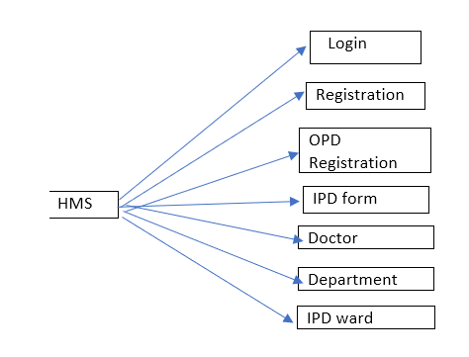

**Database Diagram:**



**ER DIAGRAM:**

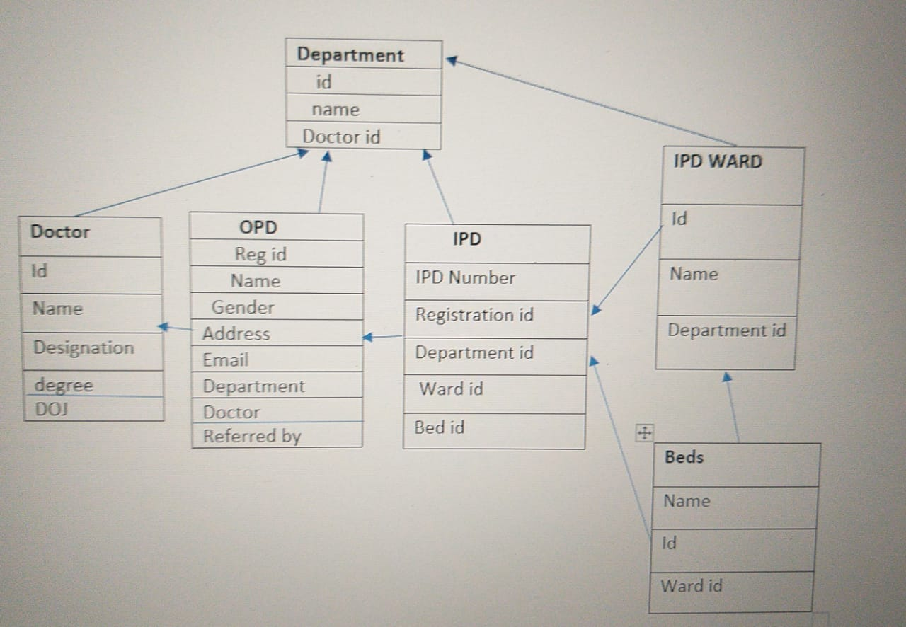

**CONCLUSION:**

Hospital management system is all about the modernizing a hospital through use of technology. Computers helps in it and take over the manual system for quick and easy functioning. This hospital management system is a quite the reliable and is proven on many stages. All the basic requirements of the hospital are provided in the hospital in order to manage it perfectly and large amount of data can also be stored it gives many facilities like searching for the detail of patient, billing facilities as well as the creation of test reports. So, it’s an important system for modern days.